Software Design Document

<Victoria Road Crash Data Software>

Group 56

s5219071 Inho Kim

s5263901 Ehkeller Hein

Table of Contents

1.0 System Vision 3

1.1 Problem Background 3

1.2 System Overview 3

1.3 Potential Benefits 3

2.0 Requirements 4

2.1 User Requirements 4

2.2 Software Requirements 4

2.3 Use Cases 4

3.0 System Components and Software Design 5

3.1 System Components 5

3.2 Software Design 5

4.0 User Interface Design 6

# System Vision

## Problem Background

The software will be developed to provide road safety data based on time, location, condition, type of collision, type of road user, object hit. based on Victoria Road Crash Dataset provided by Vircord. To reduce traffic accidents and risks in Victoria. In addition, the software analyses the point of occurrence of an accident and provides visualized insight to help user understand.

## System Overview

The system will be developed to make the people of Victoria aware of the traffic to reduce the number of accidents. It will be a python programmed software through which people of Victoria can easily trace the time, location, condition, type of collision and road user and object hit. Python will be used to develop the software.

## Potential Benefits

Not only will the number of road accidents decrease, but it will also improve the effectiveness of workers or businesses for data analysis. This software allows users to deliver data to customers easily and quickly.

# Requirements

## User Requirements

Users will need software and IDE and csv for data sets to obtain data from the software.

## Software Requirements

The program shall be written in Python Programming language.

The software shall be able to analyse the dataset and it shall be just a software through which the user will be able to see the information stored in the software.

The program shall use python strings as data structure.

## Use Cases & Use Case Diagrams

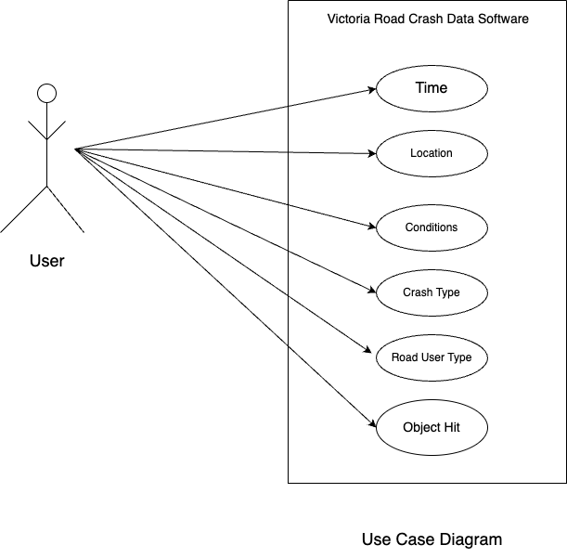

# Software Design and System Components

## Software Design

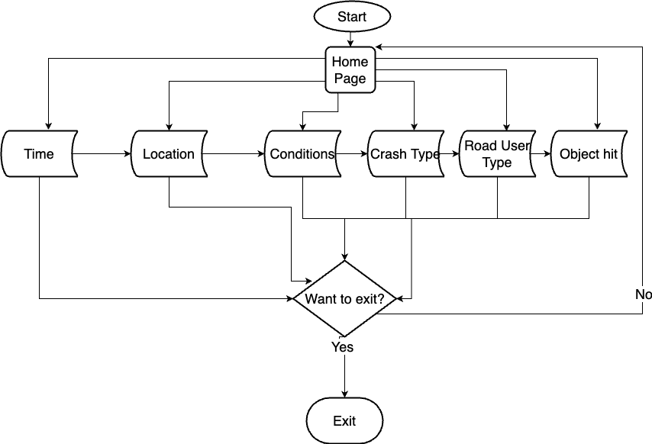

## System Components

### Functions

List of all functions which is used to develop the software:

1. Time: This function is used to highlight the time while the road accidents occurred.

Input Parameter: time().

Datatype: Datetime which was imported from Python library

2. Location: It was used to display the location of the accidents and accident prone zones.

Input Parameter: location()

Datatype: Strings.

3. Conditions: It was used to show the conditions of the traffic and road.

Input Parameter: conditions()

Datatype: Strings.

4. Crash Type: Returns the types of crash that occurred.

Input Parameter:crash_type()

Datatype: Strings.

5. Road User Type: This function was used to print the type of road users.

Input Parameter: road_user_type()

Datatype: Strings.

6.Object Hit: That function displays the type of objects hit by the vehicles.

Input Parameter: object_hit()

Datatype: Strings.

### Data Structures / Data Sources

List was used in this software frequently.

Name of functions that has used list:

1.location()

2.conditions()

3.crash_type()

4.road_user_type()

5.object_hit()

### Detailed Design

**Code:** def load_dataset(self):

df = pd.read_csv('../path/ Crash Statistics Victoria.csv’)

crash_dates = sorted(list(set(df.ACCIDENT_DATE.tolist())))

**Purpose**: The pandas function was used to read the csv file with all the data.

**Code:** def get_date(self, date):

year, month, day = date.getDate()

self.day_of_week = day_of_week(date.dayOfWeek())

self.date = f'{year}/{month}/{day}'

**Purpose:** This function lets the end user to select a date on which the user wants to get the analysed data displayed on the user interface.

**Code:** def show_chart(self, btn_type):

if self.date is None:

QMessageBox.warning(self, "Alert", "select date first")

else:

print(btn_type)

**Purpose:** This part was added for the end user to get the analysed data displayed on the user interface. If the user does not select any date, then the messagebox will retuen a warning message to the end user.

# User Interface Design

## Structural Design

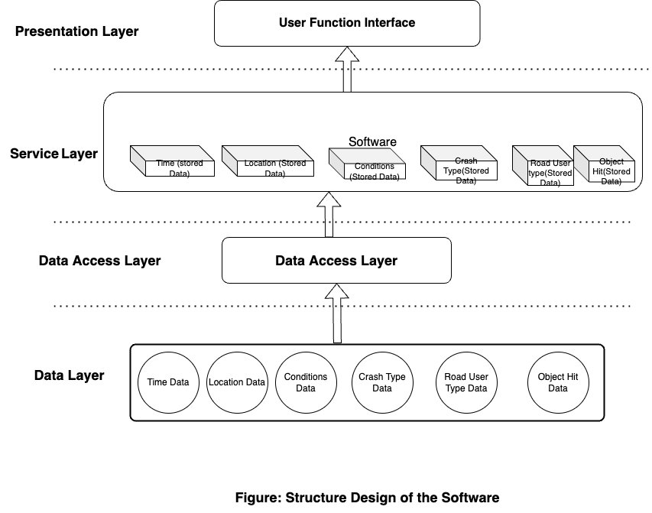 There will be 4 layers in the software as it is drawn above. The information will be stored in the data layer. The user will access through the data layer and through navigation the user will be able to see the stored data in the service layer. As this is just a simple software, the user will find it amazingly easy and convenient to use it and that is why the design will be also quite simple. This decision choice was chosen as it is remarkably simple but proficient. The interface designing is also simple. At the” Home Page”, there will be navigation buttons which will be created by Button Widgets of Python. There will also be a map where we can display the accident-prone areas of Victoria. User will find this software very convenient to use and can easily access the data stored in it.

## Visual Design

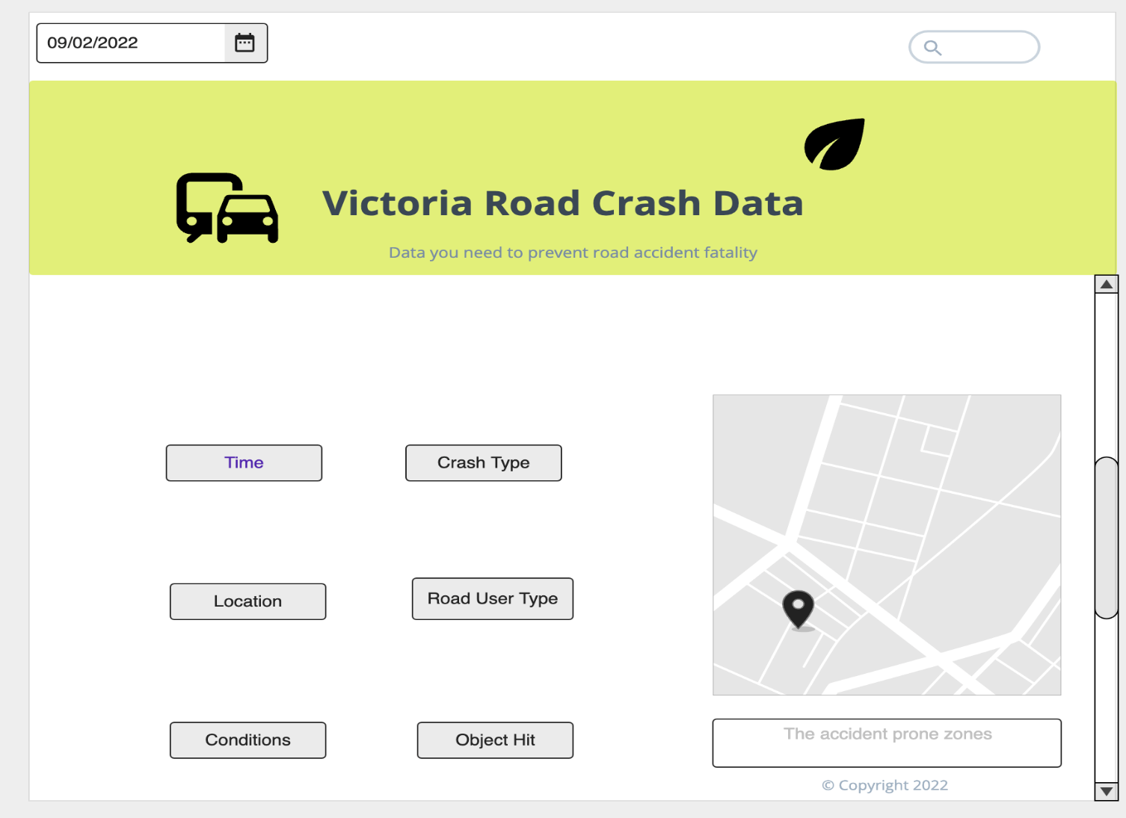

We have used an online visual design development website/tool named app.moqups.com was used to develop the visual design. This is just an initial design. We have chosen buttons in grey colour as it will be more convenient for the users to read the options of the buttons. The software name is highlighted with large fonts and it is in black colour with yellowish background. Button widget will be used to create buttons in the software.